**Web-based Ordering & Ingredient Estimating for Bakery Manufacturer**

Software Design Document

By

**Miss. Nontra Mahachanont 542115026**

**Mr. Parinya Panyanak 542115034**

Department of Software Engineering

College of Arts, Media and Technology

Chiang Mai University

Project Advisor

________________________

**Mr.Phudinan Singkhamfu**

|  |  |  |
| --- | --- | --- |
| **Software Requirement Specification** | | |
| Cross Ref. VSE-29110 | **Coverage Level:** | **Version:** |
|  | V.1.0 | V.1.0 |

|  |  |
| --- | --- |
| **Process Ownership** | **Approving Authority** |
| Web-based Ordering & Ingredient Estimating for Bakery Manufacturer | Aj.Phudinan Singkhamfu |
| **Scope** | **Approved Date** |
| Senior Project | 2 July 2014 |

|  |  |  |  |  |
| --- | --- | --- | --- | --- |
| **Version Number** | **Record Date** | **Prepared/**  **Modified By** | **Reviewed By** | **Change Details** |
| **Documents History** | | | | |
| V.0.1 | 06-05-2014 | NM, PP | NM, PP | - Add Chapter 1  - Add Chapter 2 |
| V.0.2 | 07-05-2014 | NM, PP | NM, PP | - Add Chapter 3  - Fix inappropriate words |
| V.0.4 | 09-05-2014 | NM, PP | NM, PP | - Add Chapter 4  - Fix inappropriate words |
| V.0.6 | 12-05-2014 | NM, PP | NM, PP | - Adjust Chapter 2  - Fix inappropriate words |
| V.1.0 | 24-05-2014 | NM, PP | NM, PP | - Adjust Chapter 2  - Adjust Chapter 3  - Adjust Chapter 4  - Adjust Activity Diagram |

**\*NM = Nontra Mahachanont**

**\*PP = Parinya Panyanak**

**\*PS = Phudinan Singkhamfu**

**Table of contents**

**Chapter One | System Architecture** 4

**Chapter Two | Detailed Design** 7

2.1 Class Diagram 7

2.2 Class Diagram Description 9

2.2.1 Controller Class 9

2.2.2 Model Class 13

2.3 Sequence Diagram 17

2.3.1 Admin can activate member 17

**Chapter Three | Data Architecture** 18

3.1 ER Diagram 18

3.2 ER Diagram Description 19

**Chapter Four | User Interface** 23

# **Chapter One |** **System Architecture**

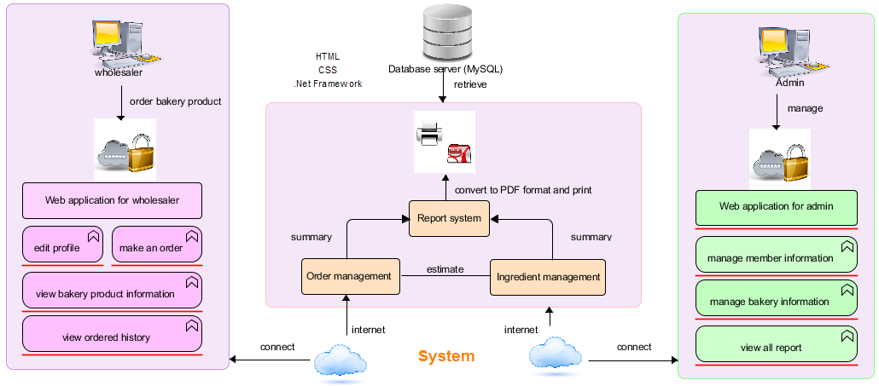

**Figure 1: Web-based Ordering & Ingredient Estimating for Bakery Manufacturer**

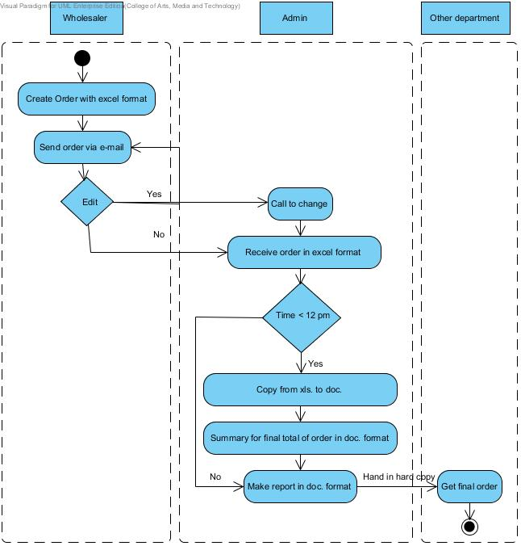

**Figure 2: Flow chart of original workflow**

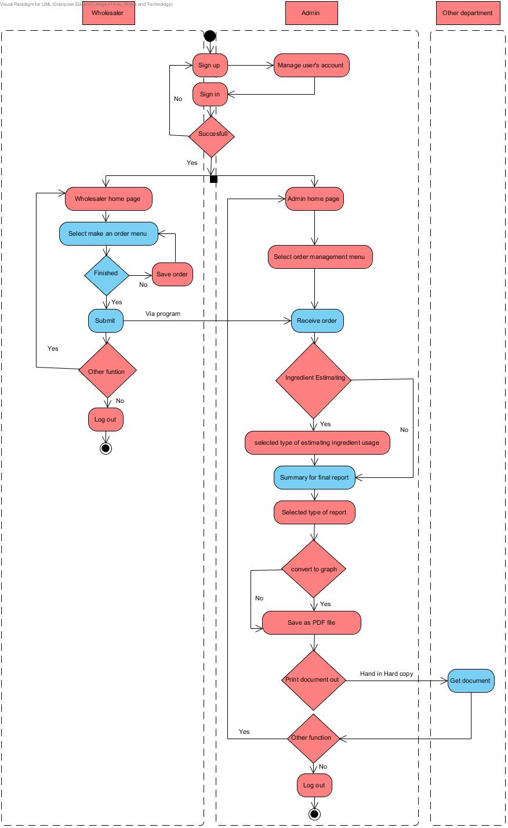

**Figure 3: Flow chart of Web-based Ordering & Ingredient Estimating for Bakery Manufacturer**

# **Chapter Two | Detailed Design**

## Class Diagram

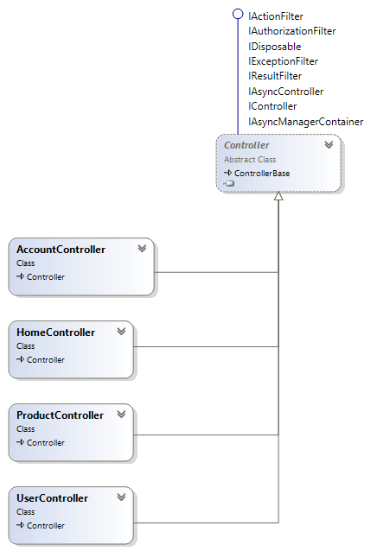

**Figure 4: Controller Class Diagram**

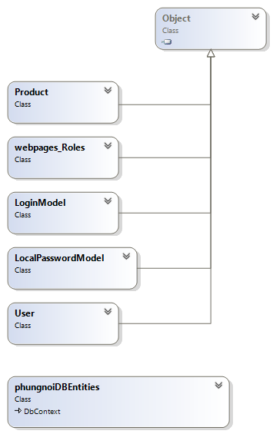

**Figure 5: Model Class Diagram**

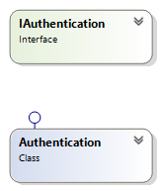

**Figure 6: service Class Diagram**

## Class Diagram Description

### 2.2.1 Controller Class

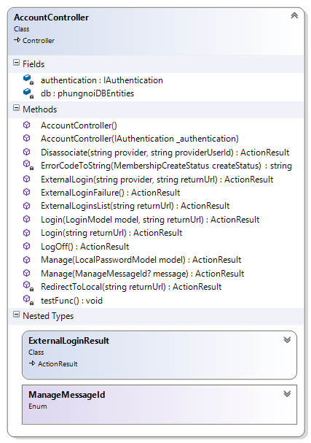

**Method:**

|  |  |  |  |
| --- | --- | --- | --- |
| **ID** | **Name** | **Description** | **Remark** |
| 1 | Login() | This method uses for logging in to the system. | **Return Type**: ActionResult  **Parameters:** model; LoginModel, returnUrl; String |
| 2 | Logoff() | This method uses to logout from the system. | **Return Type**: ActionResult  **Parameters:** - |

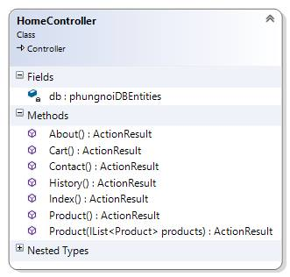

**Method:**

|  |  |  |  |
| --- | --- | --- | --- |
| **ID** | **Name** | **Description** | **Remark** |
| 1 | About() | This method uses to call view to represent the About page. | **Return Type**: ActionResult  **Parameters:** - |
| 2 | Cart() | This method uses to call view to represent the Cart page. | **Return Type**: ActionResult  **Parameters:** - |
| 3 | Contact() | This method uses to call view to represent the Contact page. | **Return Type**: ActionResult  **Parameters:** - |
| 4 | History() | This method uses to call view to represent the History page. | **Return Type**: ActionResult  **Parameters:** - |
| 5 | Index() | This method uses to call view to represent the Index page. | **Return Type**: ActionResult  **Parameters:** - |
| 6 | Product() | This method uses to call view to represent the Product page that will be shown list of product. | **Return Type**: ActionResult  **Parameters:** - |

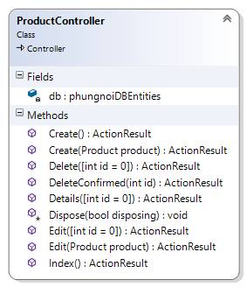

**Method:**

|  |  |  |  |
| --- | --- | --- | --- |
| **ID** | **Name** | **Description** | **Remark** |
| 1 | Create() | This method uses to call view to represent the Create page | **Return Type**: ActionResult  **Parameters:** - |
| 2 | Create(Product product) | This method used to add product in to database. | **Return Type**: ActionResult  **Parameters:** product; Product |
| 3 | Delete(int id=0) | This method uses to call view to represent the Delete page | **Return Type**: ActionResult  **Parameters:** id = 0; int |
| 4 | DeleteConfirmed(int id =0) | This method uses to delete the product in database | **Return Type**: ActionResult  **Parameters:** id; int |
| 5 | Edit(int id =0) | This method uses to call view to represent the Edit page. | **Return Type**: ActionResult  **Parameters:** id=0;int |
| 6 | Edit(Product product) | This method used to update product information. | **Return Type**: ActionResult  **Parameters:** producr;Product |
| 7 | Details(int id=0) | This method uses to call the details of the product. | **Return Type**: ActionResult  **Parameters:** int id = 0 |
| 7 | Index() | This method uses for call the index page. | **Return Type**: ActionResult  **Parameters:** - |

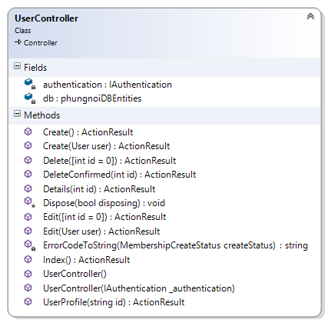

**Method:**

|  |  |  |  |
| --- | --- | --- | --- |
| **ID** | **Name** | **Description** | **Remark** |
| 1 | Create() | This method uses to call view to represent the Create page | **Return Type**: ActionResult  **Parameters:** - |
| 2 | Create(User user) | This method used to add user in to database. | **Return Type**: ActionResult  **Parameters:** user; User |
| 3 | Delete(int id=0) | This method uses to call view to represent the Delete page | **Return Type**: ActionResult  **Parameters:** id = 0; int |
| 4 | DeleteConfirmed(int id) | This method uses to delete the user in database | **Return Type**: ActionResult  **Parameters:** id; int |
| 5 | Edit(int id=0) | This method uses to call view to represent the Edit page. | **Return Type**: ActionResult  **Parameters:** id=0;int |
| 6 | Edit(User user) | This method used to update user information. | **Return Type**: ActionResult  **Parameters:** user;User |
| 7 | Details(int id=0) | This method uses to call the details of the user. | **Return Type**: ActionResult  **Parameters:** int id = 0 |
| 7 | Index() | This method uses to call the index page. | **Return Type**: ActionResult  **Parameters:** - |
| 8 | UserProfile(int id=0) | This method uses to call the UserProfile page. | **Return Type**: ActionResult  **Parameters:** int id = 0 |

### 2.2.2 Model Class

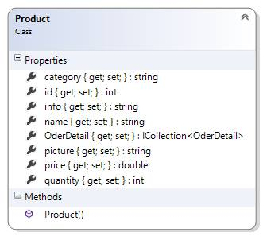

**Property:**

|  |  |  |  |
| --- | --- | --- | --- |
| **ID** | **Name** | **Description** | **Remark** |
| 1 | Category | This properties uses for storing the Product category into the database. | **Return Type**: String  **Parameters:** - |
| 2 | Id | This properties uses for storing the product id into the database. | **Return Type**: Int  **Parameters:** - |
| 3 | info | This properties uses for storing the product information into the database. | **Return Type**: String  **Parameters:** - |
| 4 | name | This properties uses for storing the product name into the database. | **Return Type**: String  **Parameters:** - |
| 5 | picture | This properties uses for storing the product picture into the database. | **Return Type**: String  **Parameters:** - |
| 6 | price | This properties uses for storing the product price into the database. | **Return Type**: String  **Parameters:** - |

**Method:**

|  |  |  |  |
| --- | --- | --- | --- |
| **ID** | **Name** | **Description** | **Remark** |
| 1 | Product() | This method a constructor of Product | **Return Type**: ActionResult  **Parameters:** - |

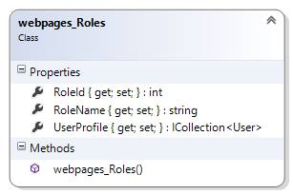

**Property:**

|  |  |  |  |
| --- | --- | --- | --- |
| **ID** | **Name** | **Description** | **Remark** |
| 1 | RoleId | This property uses for separating the role of user from the database. | **Return Type**: Int  **Parameters:** - |
| 2 | RoleName | This property uses for separating the name of user into the database. | **Return Type**: String  **Parameters:** - |
| 3 | UserProfile | This property uses for storing the product information into the database. | **Return Type**: Collection <User>  **Parameters:** - |

**Method:**

|  |  |  |  |
| --- | --- | --- | --- |
| **ID** | **Name** | **Description** | **Remark** |
| 1 | Webpage_Roles() | This method a constructor of Webpage_Roles | **Return Type**: ActionResult  **Parameters:** - |

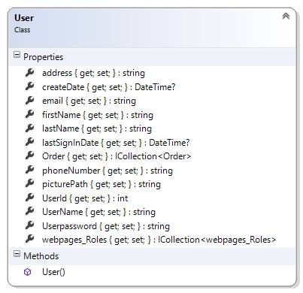

**Property:**

|  |  |  |  |
| --- | --- | --- | --- |
| **ID** | **Name** | **Description** | **Remark** |
| 1 | address | This property uses for storing the address of user into the database. | **Return Type**: String  **Parameters:** - |
| 2 | CreateDate | This property uses for storing the date of user activated into the database. | **Return Type**: DateTime  **Parameters:** - |
| 3 | firstName | This property uses for storing the first name of member into the database. | **Return Type**: String  **Parameters:** - |
| 4 | lastName | This property uses for storing the last name of member into the database. | **Return Type**: String  **Parameters:** - |
| 5 | lastSignInDate | This property uses for storing the last sign in date of member into the database. | **Return Type**: DateTime  **Parameters:** - |
| 6 | phoneNumber | This property uses for storing the phone number of member into the database. | **Return Type**: String  **Parameters:** - |
| 7 | picturePath | This property uses for storing the picture of member into the database. | **Return Type**: String  **Parameters:** - |
| 8 | userId | This property uses for storing the id of member into the database. | **Return Type**: Int  **Parameters:** - |
| 9 | userName | This property uses for storing the name of member into the database. | **Return Type**: String  **Parameters:** - |
| 10 | userPassword | This property uses for storing the password of member into the database. | **Return Type**: String  **Parameters:** - |
| 11 | Webpage_roles | This property uses for storing the role of member into the database. | **Return Type**: Collection <Webpage_roles>  **Parameters:** - |

**Method:**

|  |  |  |  |
| --- | --- | --- | --- |
| **ID** | **Name** | **Description** | **Remark** |
| 1 | User() | This method a constructor of User | **Return Type**: ActionResult  **Parameters:** - |

## https://fbcdn-sphotos-h-a.akamaihd.net/hphotos-ak-xpf1/v/t34.0-12/10515023_744250222284506_639487683_n.jpg?oh=291a48768e11855d8807d3bd8503ecd5&oe=53B9D1D4&__gda__=1404665161_f1793ba3783c5d251e2cfb1afa7015b9

**Property:**

|  |  |  |  |
| --- | --- | --- | --- |
| **ID** | **Name** | **Description** | **Remark** |
| 1 | Password | This property uses for storing the password of user into the database. | **Return Type**: String  **Parameters:** - |
| 2 | UserName | This property uses for storing the username into the database. | **Return Type**: String  **Parameters:** - |

## https://fbcdn-sphotos-h-a.akamaihd.net/hphotos-ak-xpf1/v/t34.0-12/10515023_744250222284506_639487683_n.jpg?oh=291a48768e11855d8807d3bd8503ecd5&oe=53B9D1D4&__gda__=1404665161_f1793ba3783c5d251e2cfb1afa7015b9

**Property:**

|  |  |  |  |
| --- | --- | --- | --- |
| **ID** | **Name** | **Description** | **Remark** |
| 1 | ConfirmPassword | This property uses for storing the confirm password of user into the database. | **Return Type**: String  **Parameters:** - |
| 2 | NewPassword | This property uses for storing the new password into the database. | **Return Type**: String  **Parameters:** - |
| 3 | OldPassword | This property uses for storing the old password into the database. | **Return Type**: String  **Parameters:** - |

### 2.2.3 Service Class

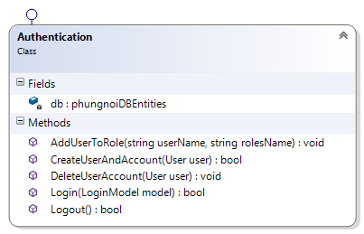

**Method:**

|  |  |  |  |
| --- | --- | --- | --- |
| **ID** | **Name** | **Description** | **Remark** |
| 1 | AddUserToRole(string username,string rolesName) | This method uses to add a role to user. | **Return Type**: void  **Parameters:** username,roleName; string |
| 2 | CreateUserAndAccount(User user) | This method uses to create new user. | **Return Type**: Boolean  **Parameters:** user; User |
| 3 | DeleteUserAccount(User user) | This method uses to delete user from database. | **Return Type**: void  **Parameters:** user; User |
| 4 | Login(LoginModel model) | This method uses to authentication before using all functional website. | **Return Type**: Boolean  **Parameters:** model; LoginModel |
| 5 | Logout():bool | This method uses to sign-out user. | **Return Type**: Boolean  **Parameters:** - |

## 

## 2.3 Sequence Diagram

### 2.3.1 Admin can activate member

**Figure 4: SD-01 Admin can activate member**

**Figure 5: SD-02 User can authentication**

**Figure 6: SD-03 Admin can manage member information**

**Figure 7: SD-04 Wholesaler can update own member information**

**Figure 8: SD-05 Admin can manage all bakery product**

**Figure 9: SD-06 Wholesaler can view all bakery product**

# **Chapter Three | Data Architecture**

## 3.1 ER Diagram

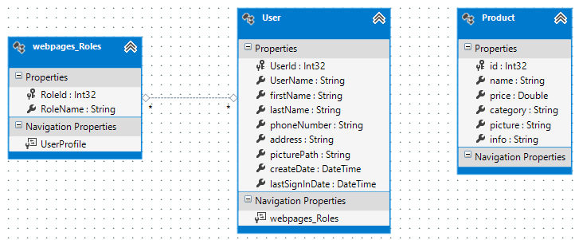

**Figure 10: ER Diagram**

## 3.2 ER Diagram Description



**DB-01: Product**

|  |  |  |
| --- | --- | --- |
| **Field** | **Type** | **Extra** |
| Category | String | - Not Null |
| Id | Int | - Primary Key  - Not Null  - Auto Incremental |
| info | String | - Not Null |
| name | String | - Not Null |
| picture | String | - Not Null |
| price | String | - Not Null |



**DB-02: Webpage_Roles**

|  |  |  |
| --- | --- | --- |
| **Field** | **Type** | **Extra** |
| RoleId | Int | - Primary Key  - Not Null  - Auto Incremental |
| RoleName | String | - Not Null |
| UserProfile | String | - Not Null |



**DB-03: User**

|  |  |  |
| --- | --- | --- |
| **Field** | **Type** | **Extra** |
| address | String | - Not Null |
| CreateDate | DateTime | - Not Null |
| firstName | String | - Not Null |
| lastName | String | - Not Null |
| lastSignInDate | DateTime | - Not Null |
| phoneNumber | String | - Not Null |
| picturePath | String | - Not Null |
| userId | Int | - Primary Key  - Not Null  - Auto Incremental |
| userName | String | - Not Null |
| userPassword | String | - Not Null |
| Webpage_roles | String | - Not Null |

# **Chapter Four | User Interface**

**Figure 10:** 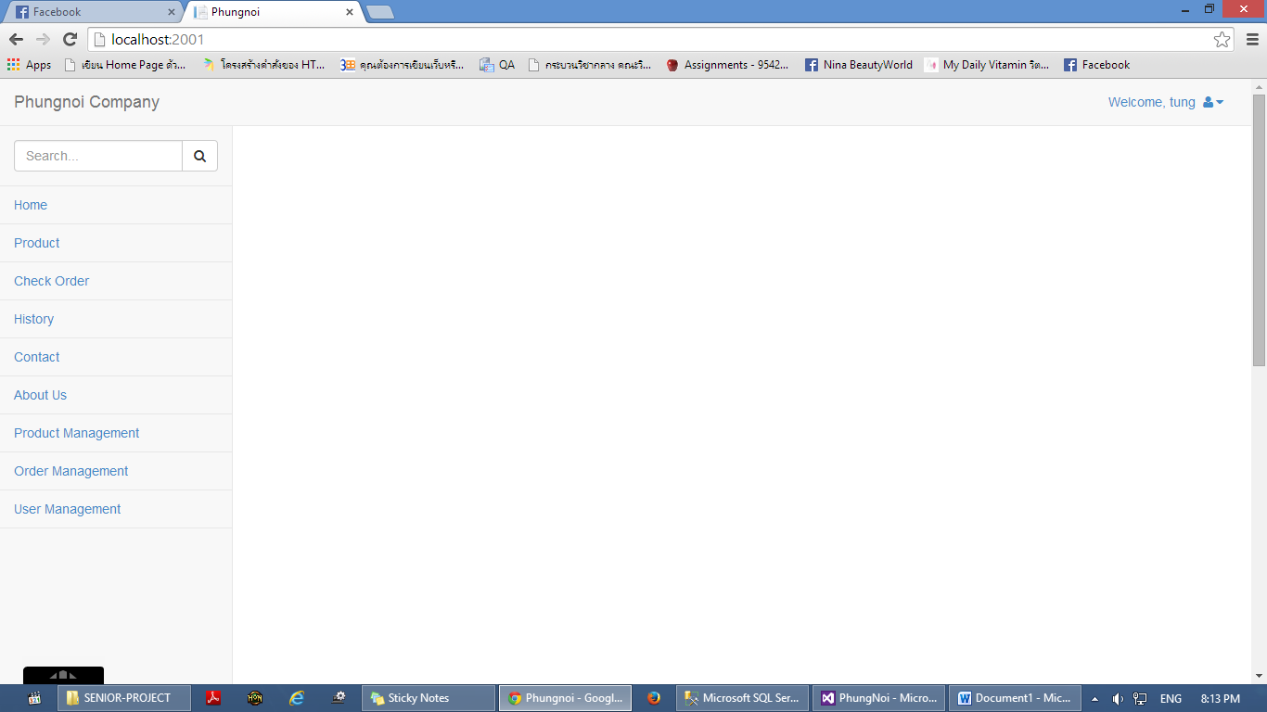UI-0 Home page

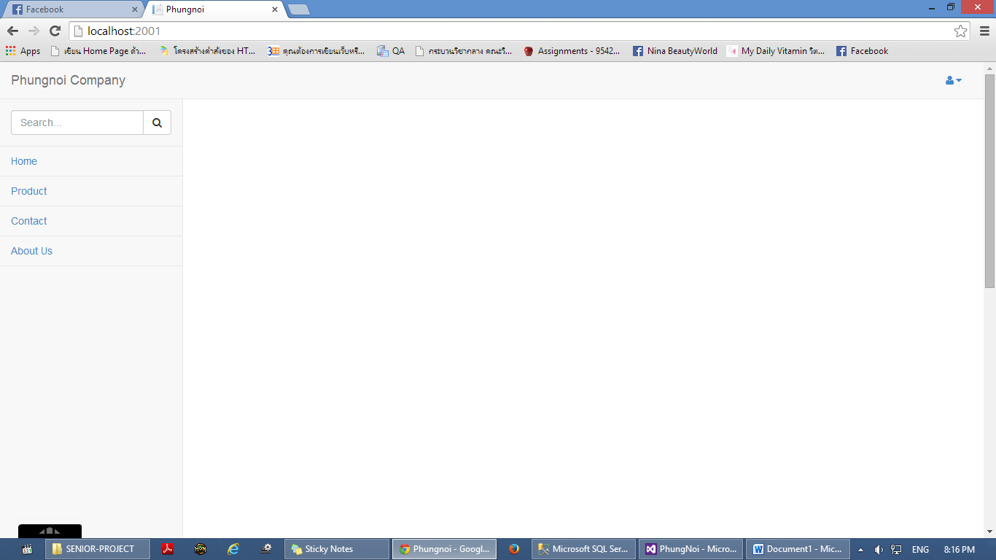**Figure 11:** UI-02 Admin main lay out

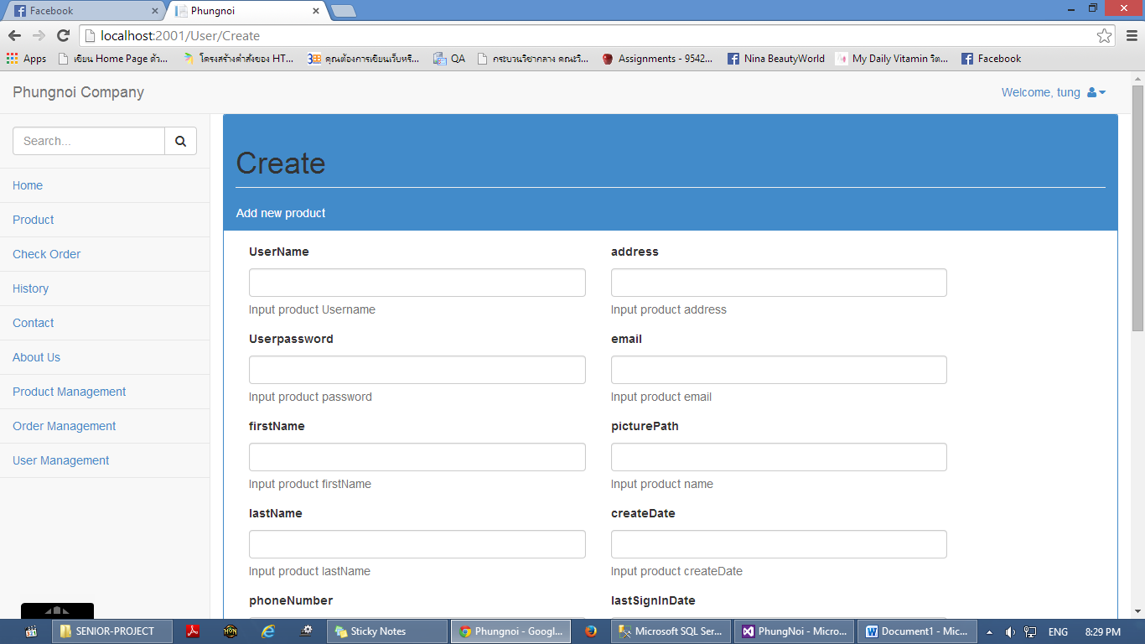**Figure 12:** UI-03Wholesaler main lay out

**Figure 13:** UI-04 Create member page

**Figure 14:** UI-05 Create success page

**Figure 15:** UI-06 Create fail page

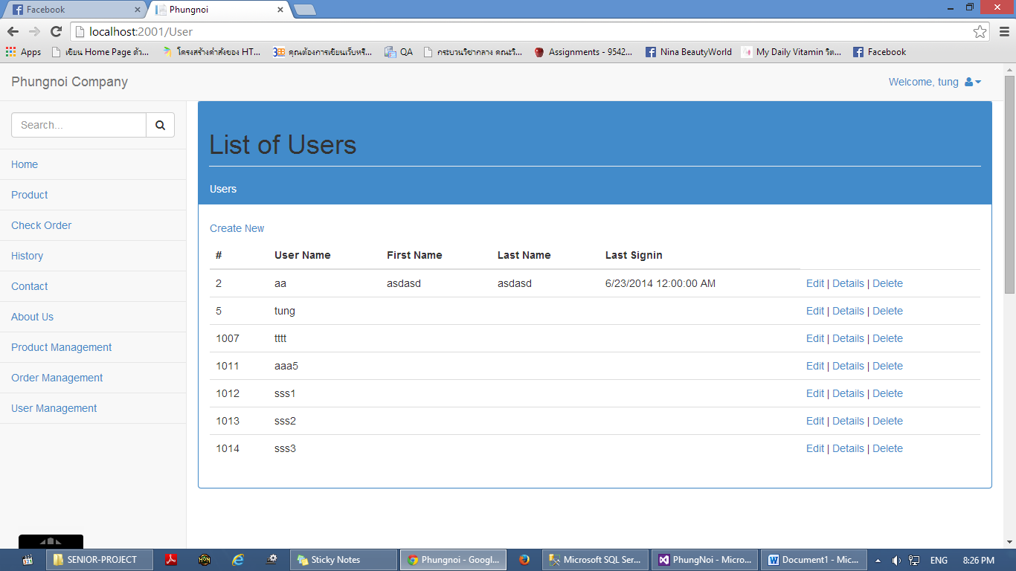**Figure 16:** UI-07 Member information page

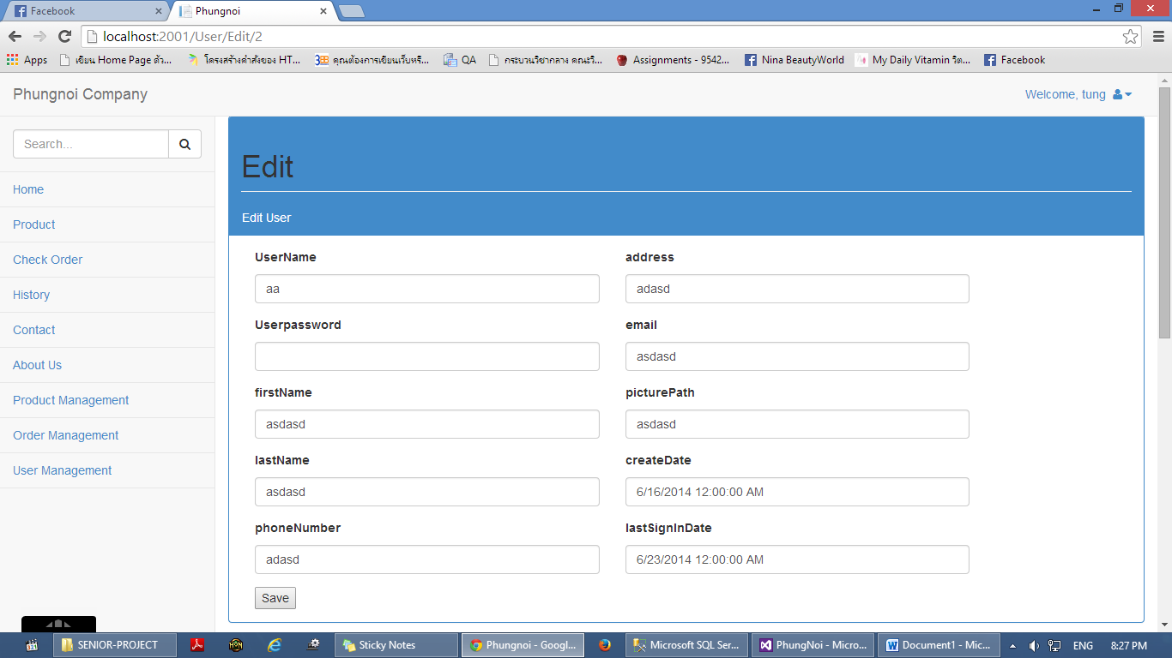**Figure 17:** UI-08 Admin view list of member

**Figure 18:** UI-09 Admin edit member information

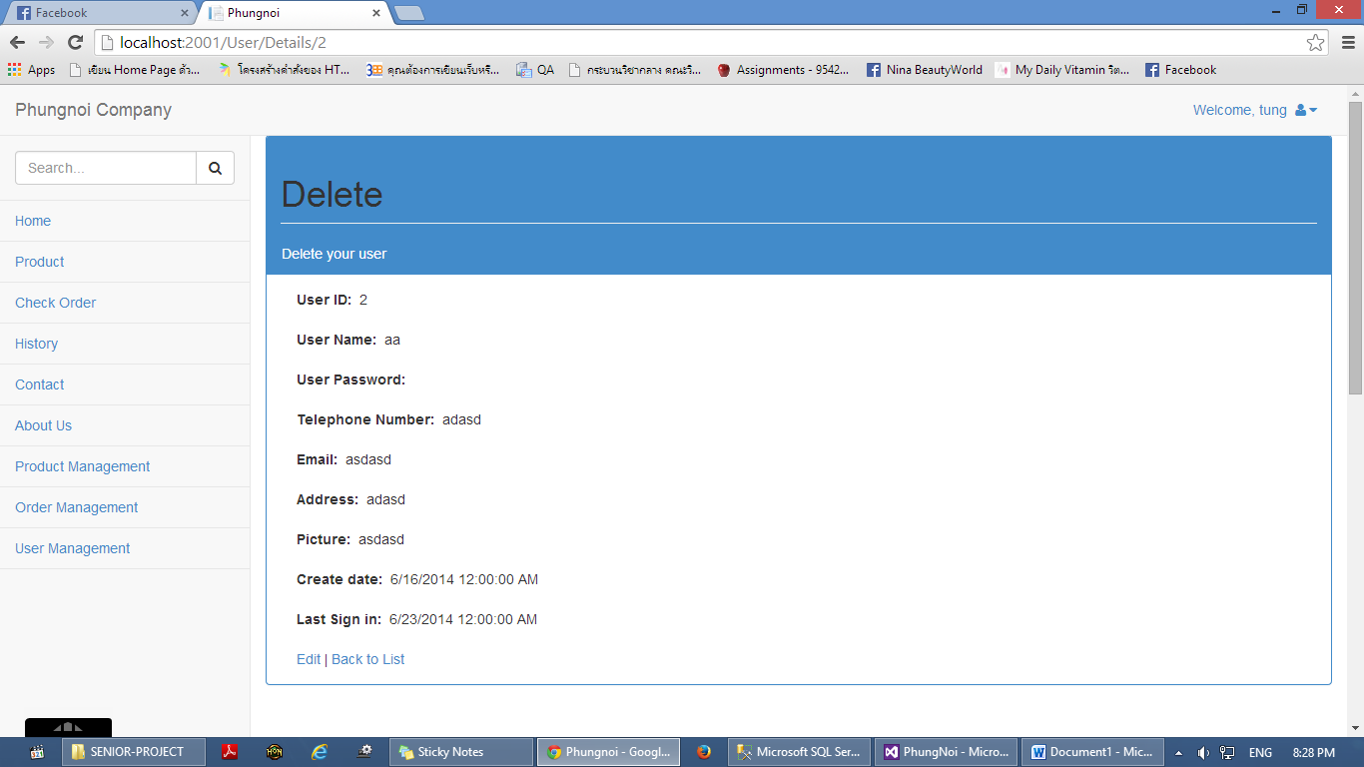

**Figure 19:** UI-10 Admin delete member information

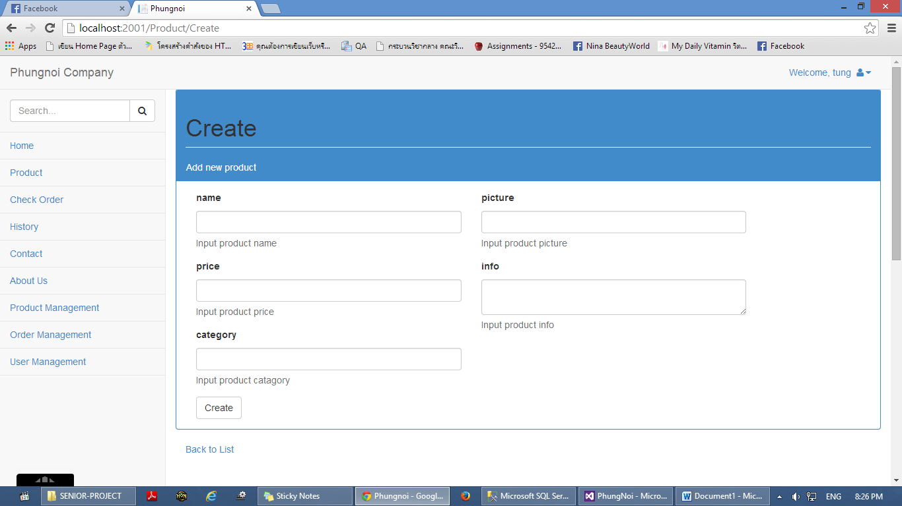**Figure 20:** UI-11Wholesaler edit own information

**Figure 21:** UI-12 Admin create bakery product

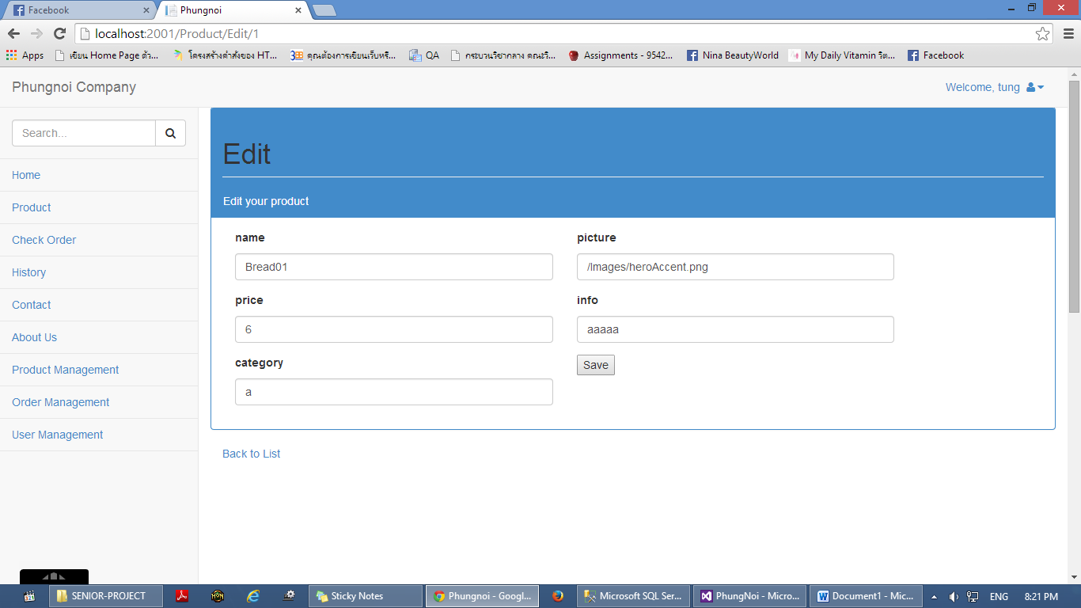

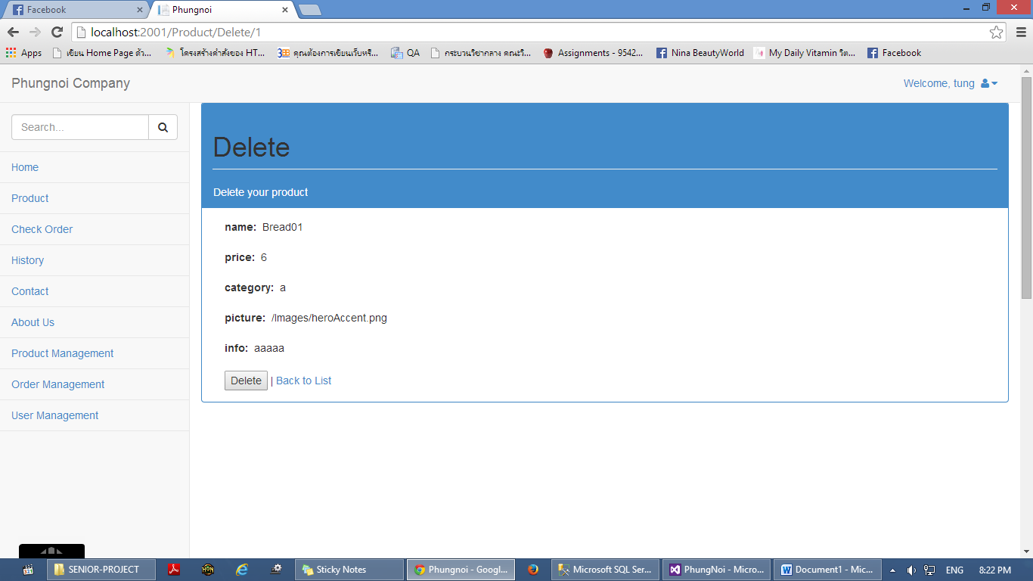**Figure 22:** UI-13 Admin edit bakery product

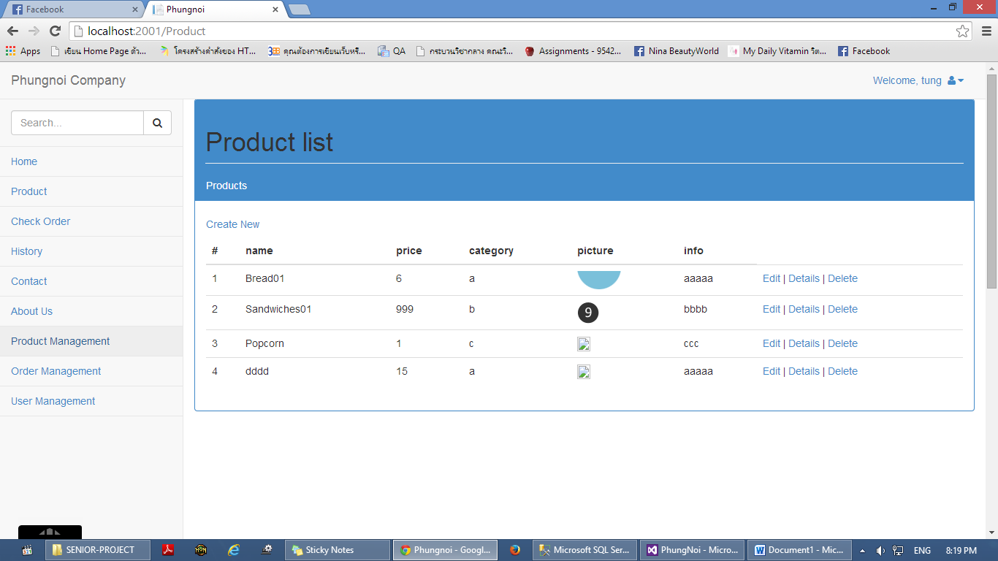**Figure 23:** UI-14 Admin delete bakery product

**Figure 24:** UI-15 Admin view list of bakery product

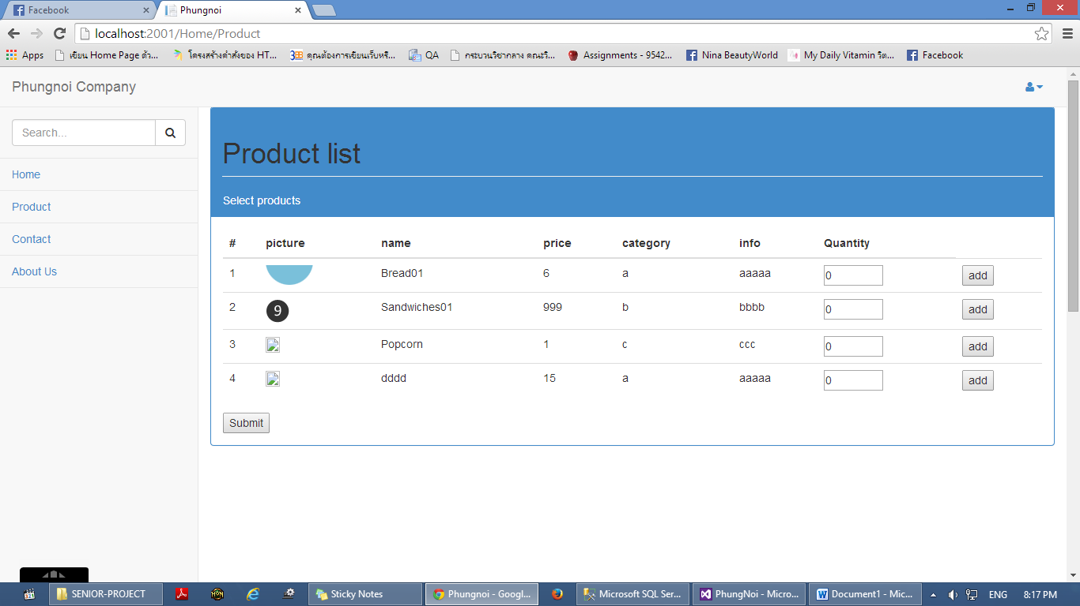

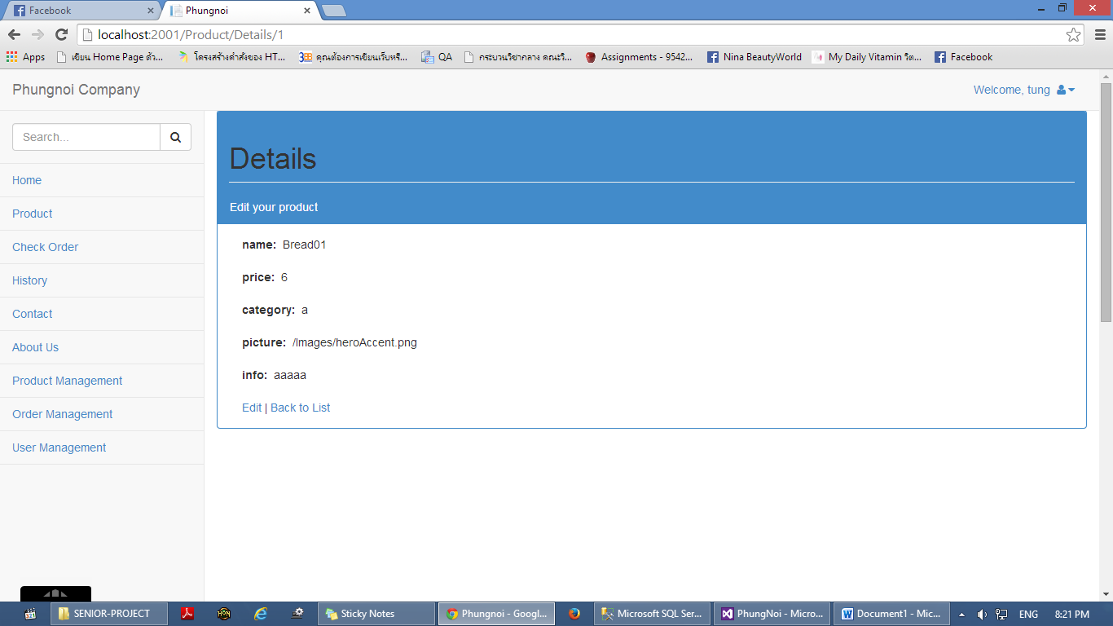**Figure 25:** UI-16Wholesaler view list of bakery product

**Figure 26:** UI-17 Bakery product information page